**AUTOMATIC CURTAIN SYSTEM**



Mini Project submitted in partial fulfillment of the requirement for the award of the

degree of

**BACHELOR OF TECHNOLOGY**

**IN**

**COMPUTER SCIENCE AND ENGINEERING**

Under the esteemed guidance of

**Dr.Zubair Ali Ansari**

**Associate Professor**

By

E.Hiranmaya Sharvani (20R11A05K3)

G.Anusha (20R11A05K5)

Y.Shiva Kumar (20R11A05Q0)



**Department of Computer Science and Engineering**

**Accredited by NBA**

**Geethanjali College of Engineering and Technology**

**(UGC Autonomous)**

(Affiliated to J.N.T.U.H, Approved by AICTE, New Delhi)

Cheeryal (V), Keesara (M), Medchal.Dist.-501 301.

**October-2023**

**Geethanjali College of Engineering & Technology**

**(UGC Autonomous)**

(Affiliated to JNTUH, Approved by AICTE, New Delhi)

Cheeryal (V), Keesara(M), Medchal Dist.-501 301.

**DEPARTMENT OF COMPUTER SCIENCE AND ENGINEERING**

**Accredited by NBA**



###### Certificate

This is to certifythat the B.Tech Mini Project report entitled **“AUTOMATIC CURTAIN SYSTEM”** is a bonafide work done by E.Hiranmaya Sharvani (20R11A05K3)

G.Anusha(20R11A05K5),Y.Shiva Kumar (20R11A05Q0), in partial fulfillment of the requirement of the award for the degree of Bachelor of Technology in “**Computer Science and Engineering**” from Jawaharlal Nehru Technological University, Hyderabad during the year 2023-2024.

**Internal Guide**  HOD - CSE

**Dr.Zubair Ali Ansari Dr SreeLakshmi**  Associate Professor Professor

External Examiner

**Geethanjali College of Engineering & Technology**

**(UGC Autonomous)**

(Affiliated to JNTUH Approved by AICTE, New Delhi)

Cheeryal (V), Keesara(M), Medchal Dist.-501 301.

**DEPARTMENT OF COMPUTER SCIENCE AND ENGINEERING**

**Accredited by NBA**



###### DECLARATION BY THE CANDIDATE

I/We, E.Hiranmaya Sharvani,G.Anusha,Y.shiva Kumar **,** bearing Roll Nos. **20R11A05K3, 20R11A05K5, 20R11A05Q0,** hereby declare that the project report entitled **“AUTOMATIC CURTAIN SYSTEM”** is done under the guidance of **Mr.** , **Associate Professor**, Department of Computer Science and Engineering, Geethanjali College of Engineering and Technology, is submitted in partial fulfillment of the requirements for the award of the degree of **Bachelor of Technology in Computer Science and Engineering**.

This is a record of bonafide work carried out by me/us in GEETHANJALI COLLEGE OF ENGNEERING AND TECHNOLOGYand the results embodied in this project have not been reproduced or copied from any source. The results embodied in this project report have not been submitted to any other University or Institute for the award of any other degree or diploma.

E.Hiranmaya Sharvani(20R11A05K3),

G.Anusha(20R11A05K5),

Y.Shiva Kumar (20R11A05Q0)

Department of CSE

Geethanjali College of Engineering and Technology,

Cheeryal.

**ACKNOWLEDGEMENT**

We are greatly indebted to the Management of Geethanjali College of Engineering and Technology, Cheeryal, Hyderabad, for providing us the necessary facilities to successfully carry out this mini project work titled **“AUTOMATIC CURTAIN SYSTEM”**. Firstly, we thank and express our solicit gratitude to Professor **Dr. A. SREE LAKSHMI,** CSE department, Geethanjali College of Engineering and Technology for her invaluable help and support which helped us a lot in successfully completing our project. Moreover, we also express our gratitude to **Dr.ZUBAIR ALI ANSARI,** Associate Professor, Geethanjali College of Engineering and Technology, our guide and patron, for his continued support throughout our endeavor to make our project successfully done. We would like to express our sincere gratitude to our Principal **Dr. S. UDAYA KUMAR** for providing the necessary infrastructure to complete our project. We convey our gratitude to our Chairman, **Mr. G. RAVINDER REDDY,** for his invaluable support and encouragement for propelling our innovation forward. Finally, we would like to express our heartfelt gratitude to our parents and all our peers who were very supportive and for their encouragement to achieve our goals.

**E.HIRANMAYA SHARVANI (20R11A05K3),**

**G.ANUSHA (20R11A05K5),**

**Y.SHIVA KUMAR (20R11A05Q0)**

**ABSTRACT**

* In today’s generation everyone are into innovative things, they find a convenient solution for improving home automation, enhancing security, and reducing energy consumption.
* This Automated Smart curtains is a home automation system designed to provide users with a convenient and efficient way to open and close their curtains.
* The system uses a motorized curtain track that can be controlled using remote, a smartphone app, or a voice assistant.
* By incorporating Ai algorithms, the system can learn the user’s preferences and habits and adjust the curtains opening and closing times accordingly.
* The AI can also take into account external factors such as weather conditions and adjust the curtains to optimize energy efficiency.
* Another feature of it is to regulate the amount of light entering the room.

**List of Screens**

S. No Title of figure Page.no

1. Normal temperature and light readings 22

2. Readings of light change in Serial Monitor 22

3. Readings of Temperature change in Serial Monitor 23

**List of Abbreviations**

S. No Abbreviations Fullform

1. DHT Digital Temperature And Humidity Sensor

2. LDR Light Dependent Resistor

**TABLE OF CONTENTS**

S. No Contents Page no

**Abstract 5**

**List of Screen shots 6**

**List of Abbreviations 6**

**1. Introduction……………………………………………………… 9**

1.1 About the project 9

1.2 Objective 9

**2. System Analysis…………………………………………………… 10**

2.1 Existing System 10

2.2 Proposed System 11

2.3 Feasibility Study 14

2.3.1 Details 14

2.3.2 Impact on Environment 14

2.3.3 Safety 14

2.3.4 Cost 14

2.3.5 Ethics 14

2.4 Scope of the Project 14

2.5 System Configuration 15

**3. Literature Overview………………………………………………. 16**

**4. System Design……………………………………………………… 17**

4.1 System Architecture 17

4.2 Requirements and their uses 17

**5. Implementation…………………………………………………….. 26**

5.1 Implementation 26

5.2 Sample code 26

**6. System Testing…………………………………………………….. 29**

6.1 Testing concepts 29

6.2 Test cases 29

**7. Output Screens……………………………………………………... 31**

**8. Conclusion………………………………………………………..… 35**

8.1 Conclusion 35

8.2 Further Enhancements 35

**9. Bibliography……………………………………………………….. 36**

9.1 Books References

**10. Plagiarism report………………………………………………….. 37**

**1.INTRODUCTION**

**1.1 ABOUT THE PROJECT**

The project uses an Arduino microcontroller board, a motor, and two sensors: a DHT sensor to measure temperature and humidity, and an LDR sensor to detect light levels. When the LDR sensor detects that the room is dark, the system sends a signal to the motor to open the curtains Similarly, If the DHT sensor detects that the temperature or humidity levels are too high the curtains automatically opens . When the LDR sensor detects that the room is bright enough, the curtains will close automatically. This project can be useful for people who want to automate their home and make their lives more convenient. It can also help save energy by reducing the need for artificial lighting and air conditioning.

**1.2**  **OBJECTIVE**

The main objective of the "Automated Smart Curtains " project is to create a system that can automatically open and close curtains based on the light levels in a room, while also monitoring temperature and humidity levels. This system aims to provide convenience and energy savings for users by automating the process of opening and closing curtains, as well as regulating the climate in a room.

1

**2. SYSTEM ANALYSIS**

**2.1 EXISTING SYSTEM**

There are several existing systems of smart curtains available on the market. These smart curtains offer automated control and additional features that provide convenience, energy efficiency, and enhanced home automation capabilities. Here are a few examples: Motorized Curtains: Motorized curtain systems consist of curtains or blinds equipped with motors that allow them to be opened or closed remotely using a smartphone app, remote control, or voice commands. These systems often come with scheduling options, allowing you to set specific times for opening and closing the curtains.

**Disadvantages of an Existing Framework**

* Dependency on Technology: Smart curtains rely on technology such as Wi-Fi, smartphone apps, or voice assistants for control.
* Smart curtain systems can be more expensive compared to traditional curtains or blinds.
* Installing smart curtains may require professional assistance, especially if it involves electrical work or integrating with existing home automation systems.

**2.2 PROPOSED SYSTEM**

The project aims to improve the overall functionality and aesthetic of the home while reducing energy consumption.We basically use light and temperature sensors in this project. These sensors detect the amount of natural light entering the room and the current temperature, allowing the curtains to adjust automatically to maintain desired lighting conditions or help regulate room temperature.This feature would allow the system to provide privacy and block out excess sunlight while still maintaining visibility and natural light.

2

**Advantages of Proposed System**

* The system optimizes energy usage by adjusting curtains based on natural light and room temperature, leading to reduced electricity consumption.
* It provides a comfortable and convenient living environment by automatically managing curtain positions in response to changing lighting conditions and temperature.
* Users can enjoy increased privacy as the system automatically closes curtains at night, shielding the interior from prying eyes.
* The system effectively uses natural sunlight for illumination and heating, resulting in energy cost savings and a more sustainable approach.
* With the ability to control curtains remotely through a mobile app or voice commands, users can manage their curtains even when they are not at home.
* By tracking and managing energy consumption associated with curtain control, users can gain insights into their energy usage patterns and make informed decisions.
* The system can seamlessly integrate with other smart devices and platforms, expanding the scope of home automation and enhancing overall convenience.
* It creates different atmospheres in rooms by automatically adjusting curtains according to the time of day or desired mood.
* The system enhances security by simulating occupancy with curtain movements, deterring potential intruders when the occupants are away.
* Incorporating machine learning, the system adapts to user preferences and behavior patterns, continuously improving its efficiency and effectiveness.
* Users can enjoy better sleep quality with the system's ability to create an ideal sleeping environment through precise lighting control. The system offers ease of use and control, benefiting individuals with mobility issues or disabilities.

**2.3 FEASIBILITY STUDY**

**2.3.1 Details**

The project is designed to provide a convenient and energy-efficient way of controlling the opening and closing of curtains in a room. The LDR sensor is used to detect the amount of natural light in the room, while the DHT sensor is used to detect the temperature and

3

humidity. Based on the readings from the LDR and DHT sensors, the system adjusts the curtains by controlling the motor, which is connected to the curtain rail. The Arduino board is programmed to receive input from the sensors and control the motor accordingly. The system can be customized to include features such as voice control or remote access, providing users with greater convenience and control over their environment. The project has the potential to save energy and lower long-term costs by regulating temperature and utilizing natural light. The cost of development will be limited to the cost of the hardware components and any tools or software needed for development. The project can be maintained by following guidelines for replacing components or updating the software

**2.3.2 Impact on environment**

Automated smart curtains project using Arduino can have a positive impact on the environment. By automating the opening and closing of curtains, it can help regulate the temperature inside a room, reducing the need for heating or cooling systems and ultimately saving energy. Additionally, the project can be designed to utilize natural light, reducing the need for artificial lighting during the day. This can help reduce energy consumption and lower carbon emissions. Overall, the project has the potential to contribute to a more sustainable and environmentally-friendly way of living.

**2.3.3 Safety**

To ensure safe operation of an automated smart curtains project, it is important to follow electrical safety guidelines during installation, design the system with appropriate fail-safes to prevent injury or damage, and implement security measures to prevent unauthorized access. Overall, by implementing appropriate safety measures, an automated smart curtains project can be designed to operate safely and reliably.

4

**2.3.4 Ethics**

When developing an automated smart curtains project using Arduino, it is important to consider privacy, accessibility, and environmental impact. This means being transparent about data collection and obtaining user consent, designing the system to be accessible to all users, and using sustainable materials.

**2.3.5 Cost**

The cost of usage will depend on the amount of electricity consumed by the system. However, since the system is designed to regulate temperature and utilize natural light, it has the potential to save energy and lower electricity costs in the long run. The cost of maintenance will also depend on the specific components used and the complexity of the system.

**2.4 Scope**

The scope of an automated smart curtains project using Arduino, LDR, and DHT sensors is to provide a convenient and energy-efficient way of controlling the opening and closing of curtains in a room. The project can be designed to automatically adjust the curtains based on the amount of natural light and temperature in the room, helping to regulate the temperature and reduce the need for heating or cooling systems. Additionally, the project can be customized to include features such as voice control or remote access, providing users with greater convenience and control over their environment. Overall, the scope of the project is to provide a sustainable, efficient, and customizable way of controlling curtains in a room.

**2.5. SYSTEM CONFIGURATION**

**2.5.1. Hardware Requirements**

* Arduino
* LDR (Light Dependent Resistor)
* DHT11
* Servo Motor
* Power Supply

5

**2.5.2. Software Requirements**

* Operating system : Windows7 (Min).
* Coding Language : C
* Platform : Arduino Software

6

**3. LITERATURE OVERVIEW**

**Title: "Smart Curtain Control System using Arduino and LDR Sensor"**

https://www.ijert.org/smart-curtain-control-system-using-arduino-and-ldr-sensor

This paper describes the design and implementation of a smart curtain control system that uses an Arduino microcontroller board and an LDR sensor to detect light levels in a room. The system is capable of automatically opening or closing curtains based on the light levels detected by the sensor, and can also be controlled manually using a remote control. The paper includes details on the hardware and software components used in the system, as well as the testing and validation process.Overall, these papers provide valuable insights into the design, implementation, and testing of automated smart curtains using sensors and Arduino, and can be useful references for anyone interested in developing their own smart home automation system.

**Title: "Smart Automated Curtain System using Arduino and LDR Sensor"**

https://ieeexplore.ieee.org/document/8626965

This paper describes the design and implementation of an automated curtain system using an Arduino microcontroller board, an LDR sensor, and a motor. The system is capable of detecting the presence or absence of individuals in a room and opening or closing curtains accordingly based on the light levels detected by the sensor. The paper also includes details on the hardware and software components used in the system, as well as the testing and validation process.

**Title: "Automated Curtain System with Arduino and DHT Sensor"**

https://www.ijitee.org/wp-content/uploads/papers/v8i6/F7565078619.pdf

This paper presents an automated curtain system that uses an Arduino microcontroller board, a DHT sensor, and a motor to detect temperature and humidity levels in a room and open or close curtains accordingly. The paper includes details on the hardware and software components used in the system, as well as the testing and validation process.

7

**4. SYSTEM DESIGN**

**4.1 SYSTEM ARCHITECTURE**

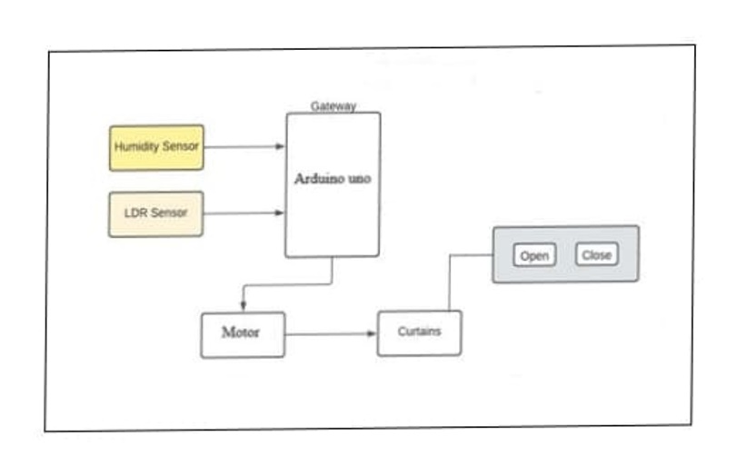

Fig. 4.1 System Architecture

**4.2 Requirements and their uses**

* ARDUINO UNO
* DHT11 SENSOR
* LDR SENSOR
* DC/SERVO MOTOR
* BREADBOARD AND CONNECTING WIRES
* RESISTOR

**4.2.1 Arduino uno**

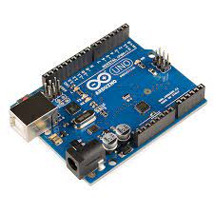

Arduino is a microcontroller board that can be used to control the motor and read input from the sensors in an automated smart curtains project. The board can be programmed to open or close the curtains based on the input from the sensors. Arduino is a versatile and affordable microcontroller board that is suitable for various DIY projects, including automated smart curtains using sensors and motors.

**4.2.2 DHT11 Sensor**

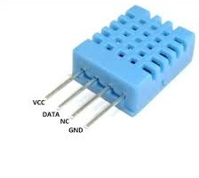

DHT11 sensor is used to measure temperature and humidity levels in the surrounding environment. In the context of an automated smart curtains ,the DHT11 sensor can be used to detect changes in temperature and humidity levels inside a room. This information can then be used to automatically adjust the curtains accordingly.Overall, the DHT11 sensor can be a useful component in an automated smart curtains project as it allows for automatic adjustment of the curtains based on changes in temperature and humidity levels.

**4.2.3 LDR Sensor**

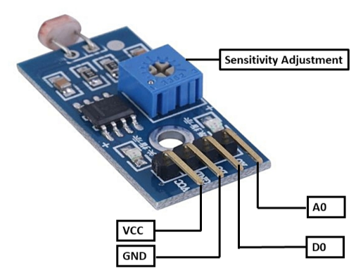

The LDR (Light Dependent Resistor) sensor is used to detect changes in light levels in the surrounding environment. In an automated smart curtains, the LDR sensor can be used to automatically adjust the curtains based on changes in light levels. During the daytime, the LDR sensor can detect high levels of light and trigger the curtains to close, blocking sunlight and reducing the temperature inside the room. During the nighttime, the LDR sensor can detect low levels of light and trigger the curtains to open, creating a comfortable ambiance inside the room. Overall, the LDR sensor is a useful component in an automated smart curtains project.

**4.2.4 Servo/Dc Motor**

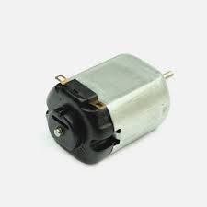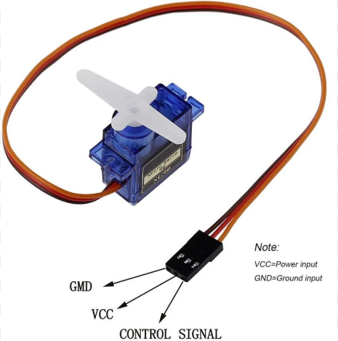

DC motors are commonly used for opening and closing the curtains quickly and efficiently. They are simple and affordable, making them a popular choice for automated smart curtains projects. Servo motors are more precise and accurate than DC motors. Both Motors can be used for precise positioning of the curtains, and have a built-in feedback mechanism that allows them to maintain a specific position or angle. They are ideal for precise positioning of the curtains.

**4.2.5 Breadboard and Connecting Wires**

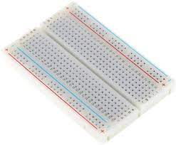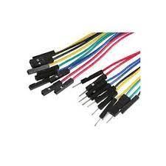

Breadboards are used for quick and solderless prototyping of electronic circuits, while connecting wired establish temporary electrical connections between components, allowing for easy testing and experimentation.

**4.2.6 Resistor**

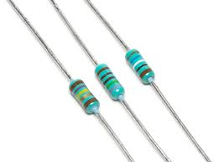

Resistors are used to limit current, create voltage dividers, set signal levels, and control various electrical properties in electronic circuits. In automated smart curtains,resistors are primarily used for current limiting and maintaining defined logic levels in digital circuits.

**5. IMPLEMENTATION**

**5.1. Arduino Software**

Programs written using Arduino Software (IDE) are called **sketches**. These sketches are written in the text editor and are saved with the file extension . ino . The editor has features for cutting/pasting and for searching/replacing text. The message area gives feedback while saving and exporting and also displays errors. The console displays text output by the Arduino Software (IDE), including complete error messages and other information. The bottom righthand corner of the window displays the configured board and serial port. The toolbar buttons allow you to verify and upload programs, create, open, and save sketches, and open the serial monitor.

**5.2. SOURCE CODE**

#include <Servo.h>

#include <dht.h>

#define LDR_PIN A0

#define DHT_PIN 2

#define SERVO_PIN 9

#define LIGHT_THRESHOLD 500

#define TEMPERATURE_THRESHOLD 25

dht DHT;

Servo myservo;

void setup() {

Serial.begin(9600);

myservo.attach(SERVO_PIN);

}

10

void loop() {

int lightValue = analogRead(LDR_PIN);

int chk = DHT.read11(DHT_PIN);

float temperature = DHT.temperature;

Serial.print("Light Value: ");

Serial.println(lightValue);

Serial.print("Temperature: ");

Serial.println(temperature);

if (lightValue < LIGHT_THRESHOLD && temperature > TEMPERATURE_THRESHOLD) {

closeCurtains();

} else {

openCurtains();

}

delay(5000);

}

void openCurtains() {

myservo.write(0); // Adjust the angle as needed to open the curtains//90

}

void closeCurtains() {

myservo.write(90); // Adjust the angle as needed to close the curtains//180

}

11

**6. SYSTEM TESTING**

**6.1 TESTING CONCEPTS**

* Functional testing: Ensure that the curtains open and close correctly based on sensor inputs or remote control commands.
* Performance testing: Verify that the system performs well under different conditions, such as responsiveness and speed of curtain movement.
* Compatibility testing: Check if the system works seamlessly with various devices and platforms, like testing the mobile app on different smartphones or operating systems.
* Security testing: Validate the system's security measures, such as encryption to protect user data and resistance to hacking or malware.

**6.2 TEST CASES**

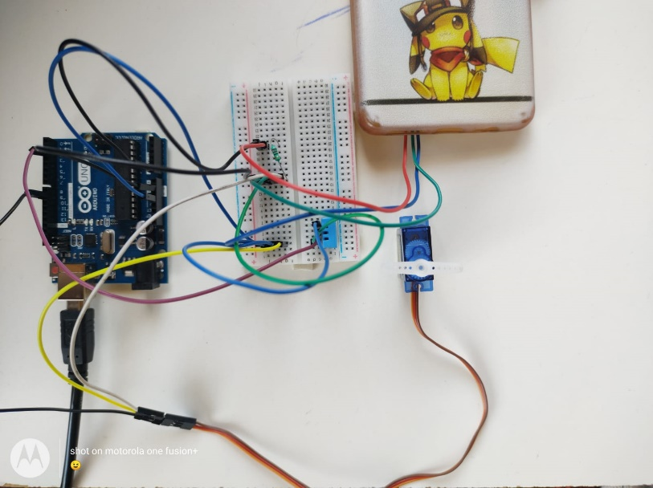

Fig.6.2.1 Response of Smart Curtain(Motor) when it is dark

12

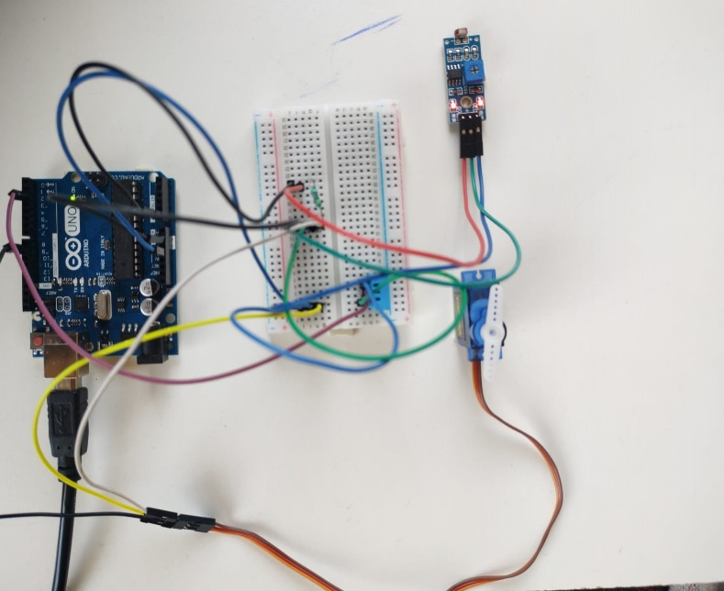

Fig.6.2.2.Response of the Smart curtain when the temperature id normal.

13

**7. OUTPUT SCREENS**

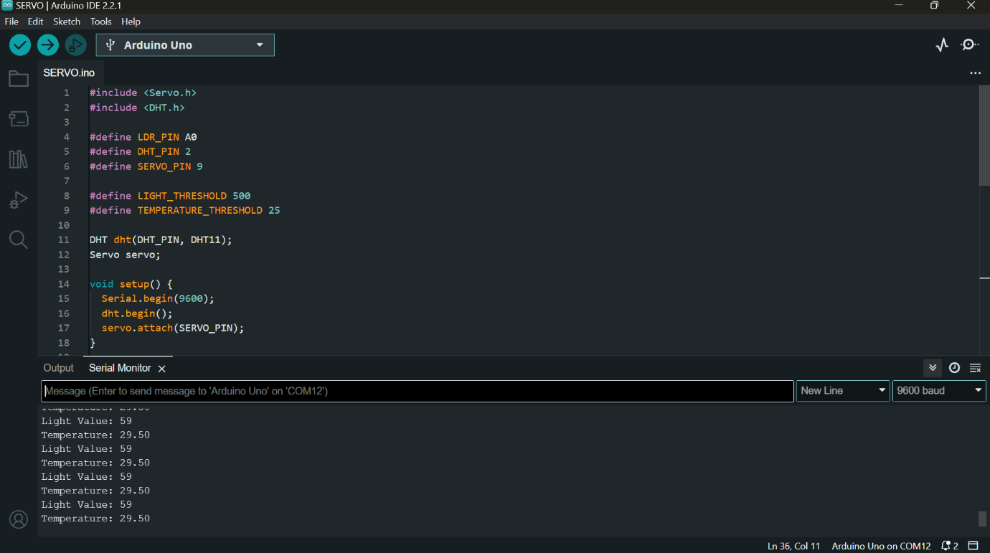

Fig.7.1 Output Screen of the normal temperature and light readings

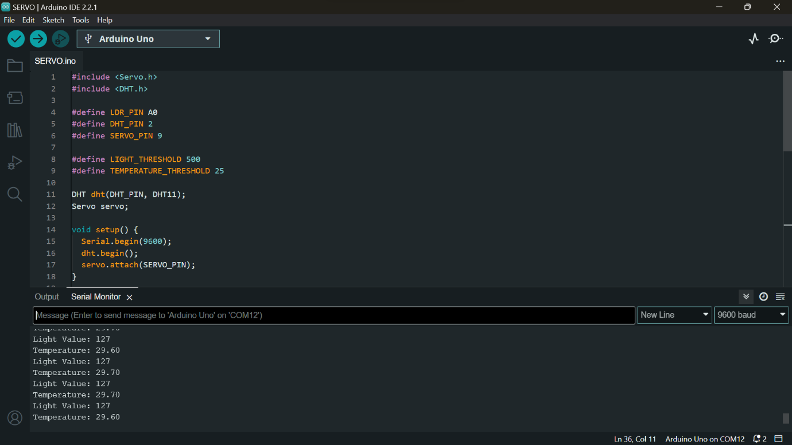

Fig.7.2 Output Screen when there is change in light readings

14

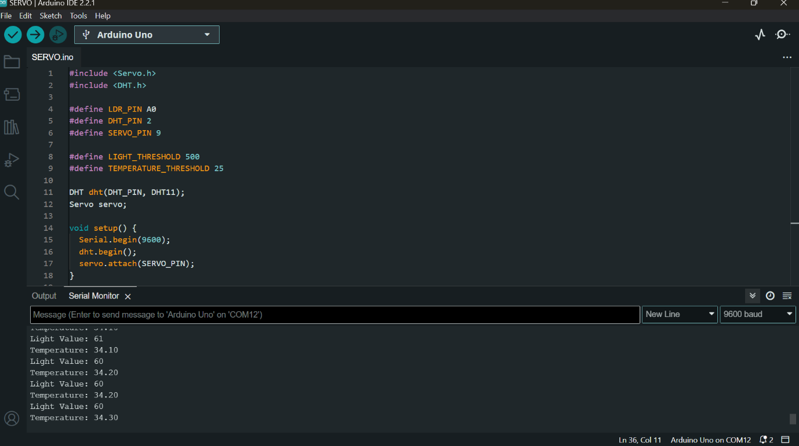

Fig.7.3 Output Screen when there is change in temperature

15

**8. CONCLUSION**

**8.1 CONCLUSION**

Based on the project "Automated Smart Curtains using Arduino, DHT Sensor, and LDR Sensor", it can be concluded that the use of Arduino microcontroller boards and sensors can be an effective way to automate the process of opening and closing curtains based on the light levels in a room, while also monitoring temperature and humidity levels. The system provides convenience and energy savings for users by automating the process of opening and closing curtains, as well as regulating the climate in a room. The project can be useful for people who want to automate their home and make their lives more convenient, while also saving energy. Overall, the development of automated smart curtains using sensors and Arduino has the potential to revolutionize home automation and provide users with a more convenient and energy-efficient way of managing their homes.

**8.2 FURTHER ENHANCEMENTS**

* Voice control: The system can be integrated with a voice assistant such as Amazon Alexa or Google Home, allowing users to control the curtains using their voice.
* Automatic scheduling: The system can be programmed to automatically open and close the curtains at specific times of the day, based on the user's schedule or preferences.
* Multiple sensor integration: The system can be enhanced by integrating multiple sensors such as motion sensors, temperature sensors, and humidity sensors, to provide more accurate and comprehensive data for curtain control.
* Smart blinds: The system can be extended to work with smart blinds, allowing users to control both curtains and blinds using the same system.
* Mobile app integration: The system can be integrated with a mobile app, allowing users to control the curtains remotely from their smartphones.

16

**9. BIBLOGRAPY**

**9.1 Book references**

[1]. R. S. Chavan, S. V. Kulkarni, A. N. Patil, and S. P. Patil. "Smart Home Automation Using IoT and Arduino." International Journal of Engineering Research & Technology, vol. 7, no. 2, 2018, pp. 141-147.

[2]. S. M. Kadam, S. M. Kadam, and P. R. Kumbhar. "Smart Curtain Control System Using Arduino." International Journal of Engineering Research & Technology, vol. 6, no. 9, 2017, pp. 186-190.

[3]. H. M. Al-Hamadi and A. A. Al-Raweshidy. "Smart Home Automation System Using Arduino and Wi-Fi." International Journal of Advanced Computer Science and Applications, vol. 9, no. 10, 2018, pp. 256-262.

[4]. A. Boudali, M. Aitouche, and S. Zouaoui. "Smart Home Automation System Based on Arduino and Android." International Journal of Computer Applications, vol. 176, no. 2, 2018, pp. 32-38.

17

## **10.PLAGIARISM REPORT**

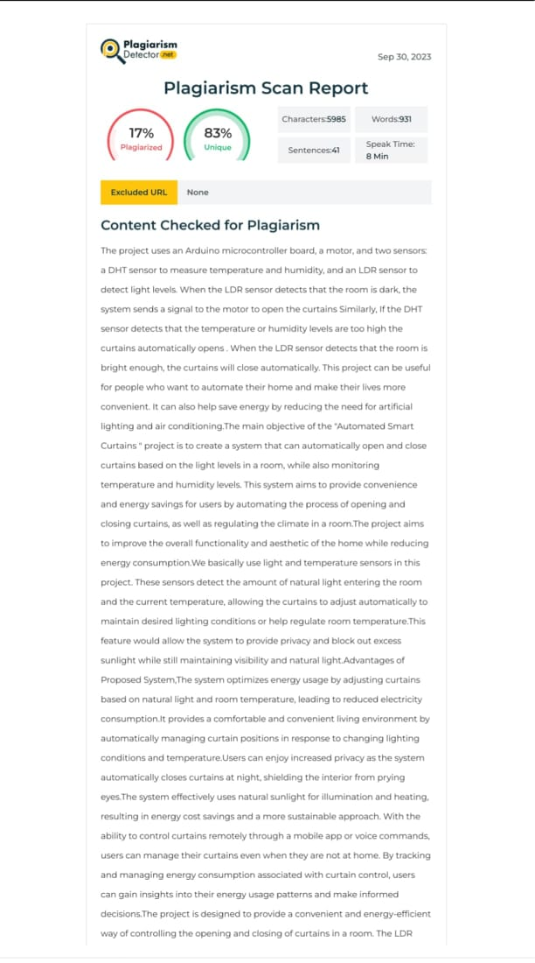

18

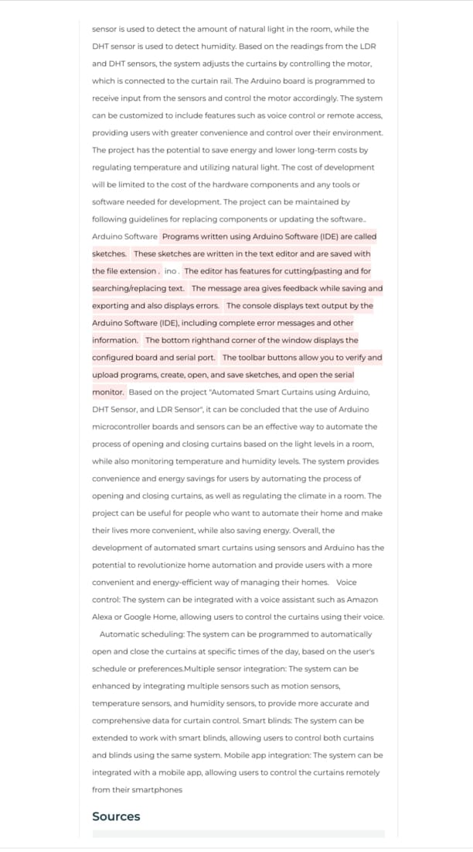

19

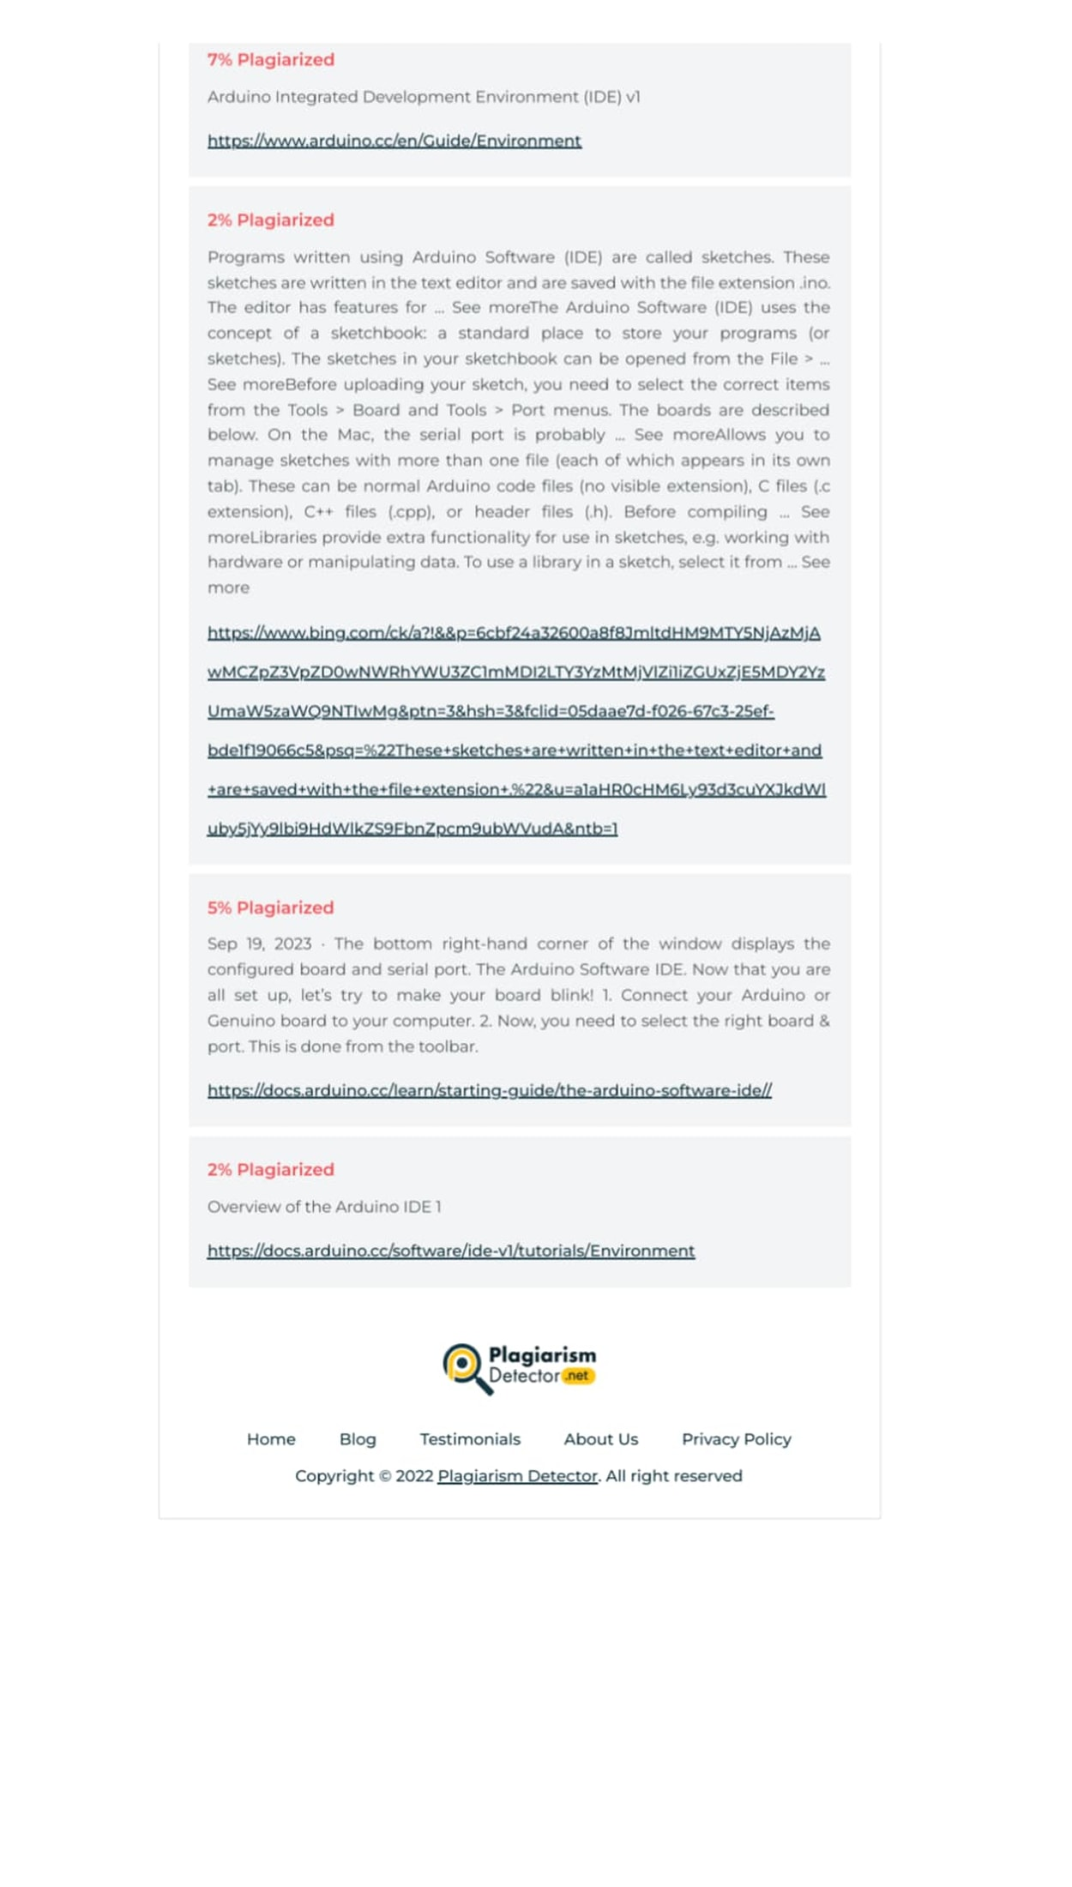

20